**ASSIGNMENT - 9**

1. What is a lambda function in Python, and how does it differ from a regular function?

Ans: Python Lambda Functions are anonymous function means that the function is without a name.

A lambda function is an anonymous function (i.e., defined without a name) that can take any number of arguments but, unlike normal functions, evaluates and returns only one expression. Note that, unlike a normal function, we don't surround the parameters of a lambda function with parentheses.

1. Can a lambda function in Python have multiple arguments? If yes, how can you define and use them?

Ans: A lambda function can take any number of arguments, but can only have one expression.

# Syntax of lambda

lambda argument, [argument, argument]: expression

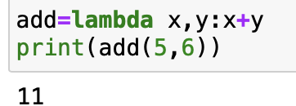

1. How are lambda functions typically used in Python? Provide an example use case.

Ans: Python Lambda Functions are anonymous function means that the function is without a name. As we already know that the def keyword is used to define a normal function in Python. Similarly, the lambda keyword is used to define an anonymous function in Python.

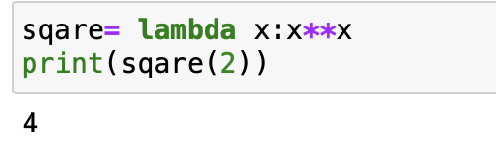

1. What are the advantages and limitations of lambda functions compared to regular functions in Python?

Ans: **Lambda Advantages.**

* The code is simple and clear.
* No additional variables are added.

#### Lambda Disadvantages.

* Lambda expressions are a strange and unfamiliar syntax to many Python programmers.
* Lambda functions themselves lack names and documentation, meaning that the only way to know what they do is to read the code.
* Lambda expressions can only contain one statement, so some readable language features, such as tuple unpacking, cannot be used with them.

### **Major Differences Between Lambda Expressions And Named Functions.**

* Can be passed immediately (without variables).
* Only one line of code can be included internally.
* Automatic return of results.
* There is neither a document string nor a name.

1. Are lambda functions in Python able to access variables defined outside of their own scope?

Explain with an example.

Ans: Lambda functions have their own local namespace and cannot access variables other than those in their parameter list and those in the global namespace.

1. Write a lambda function to calculate the square of a given number.

Ans: 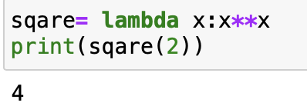

1. Create a lambda function to find the maximum value in a list of integers.

Ans: 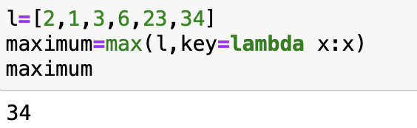

1. Implement a lambda function to filter out all the even numbers from a list of integers.

Ans:

1. Write a lambda function to sort a list of strings in ascending order based on the length of each string.

1. Create a lambda function that takes two lists as input and returns a new list containing the common elements between the two lists.

1. Write a recursive function to calculate the factorial of a given positive integer.

Ans: 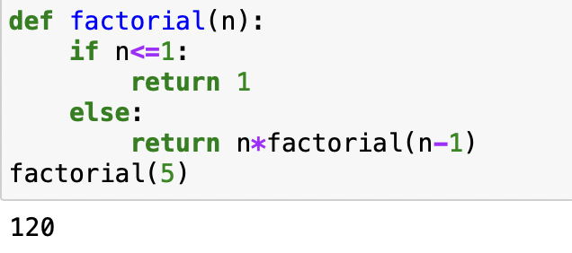

1. Implement a recursive function to compute the nth Fibonacci number.

Ans: 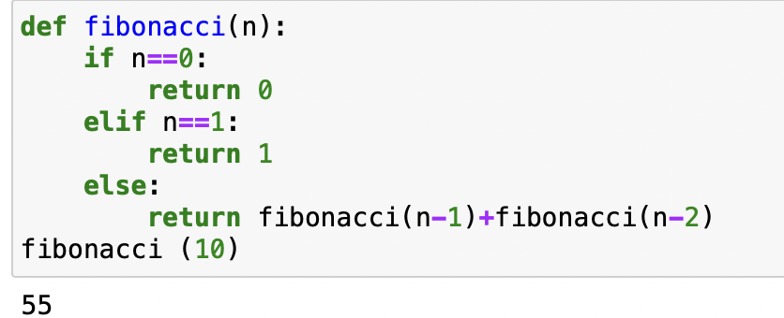

1. Create a recursive function to find the sum of all the elements in a given list.

Ans: 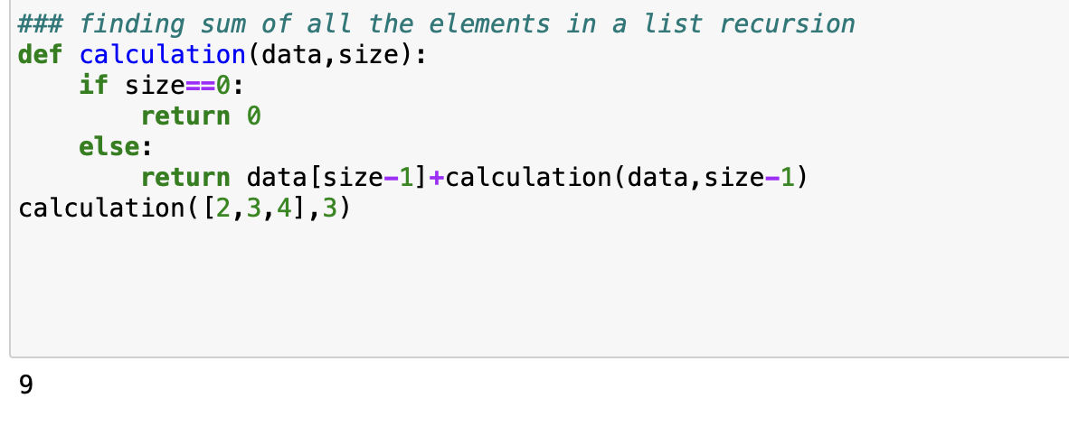

1. Write a recursive function to determine whether a given string is a palindrome.

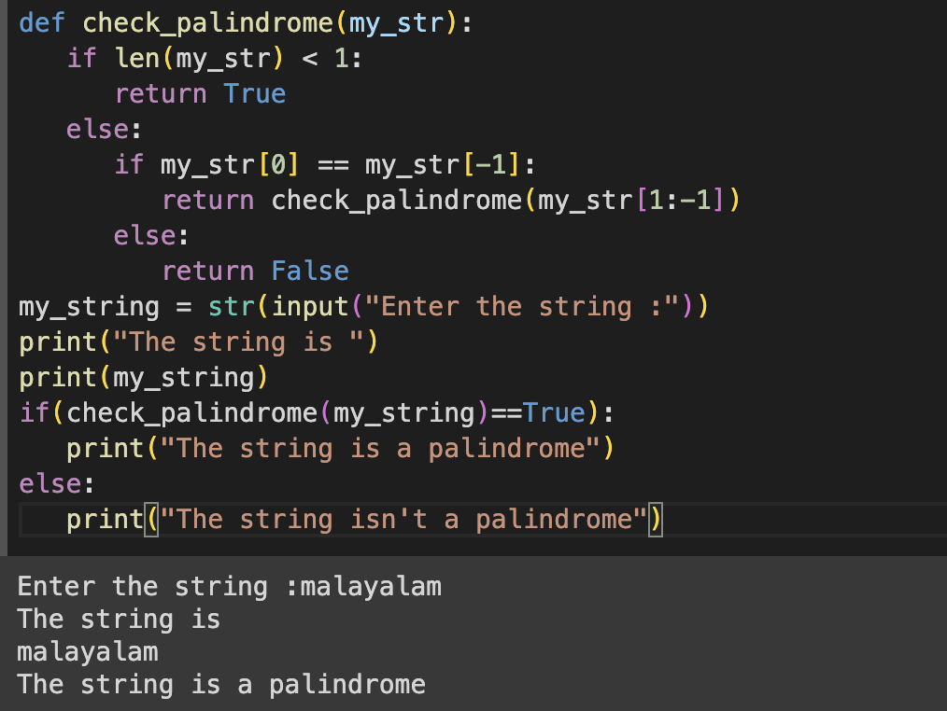

1. Implement a recursive function to find the greatest common divisor (GCD) of two positive integers.

